Design blog
COMM1790
201909224

1 - Style Guides and Design Systems

Style guides are rules for branding and aesthetics and are the content standards. They focus on format, font, and color including rules and regulations for writing style and tone, branding and design, color, images, and logo history. Their purpose is to incorporate style guides such as consistency for structure and appearance and brand alignment to reinforce brand identity, according to Nielsen Norman Group (2021). According to Campbell (2020), grammar syntax and logo usage are also beneficial when using style guides. They help establish rules and correctness and the correct use of size, spacing, and positioning of the brand’s logo, respectively. Also, imagery, layout, color palette, and typography are significant as they produce the final result. Examples of style guides include many worldwide companies such as IKEA, Uber, and Skittles. These companies use a specific writing style guide to differentiate themselves from other companies in order to have a unique name.

Design systems are more complex than style guides. They consist of popular, corporate, and open-source design systems. Spotify is a good example of a design system, it is known by its distinct, vibrant green color, which is one of the features of design systems. Nike’s famous logo of the swoosh identifies the brand identity without the need to have the name under the logo. The design is considered popular as it has a name for itself. Design systems are more dependent on the structure of the design, whereas style guides focus more on the wording and image of the design.

2 - Fundamentals of Composition
- Visual Alignment

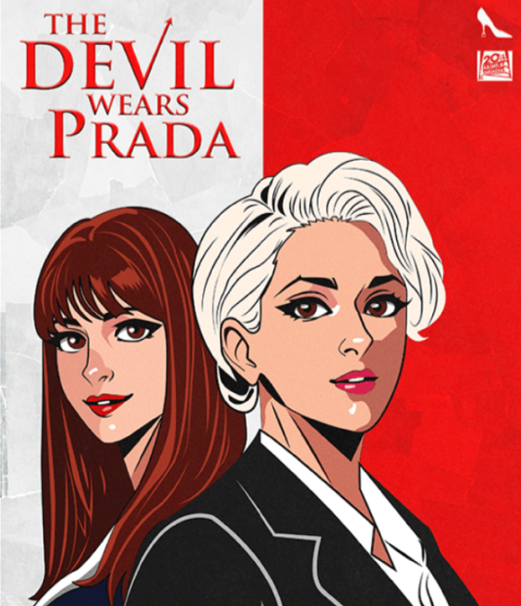

https://www.behance.net/gallery/207113783/IllustrationsManga-Female Icons/modules/1176134075

This picture has elements of edge alignment on the top left and right, and visual alignment on the bottom left of the characters designed as cartoon visuals.

- Center Alignment

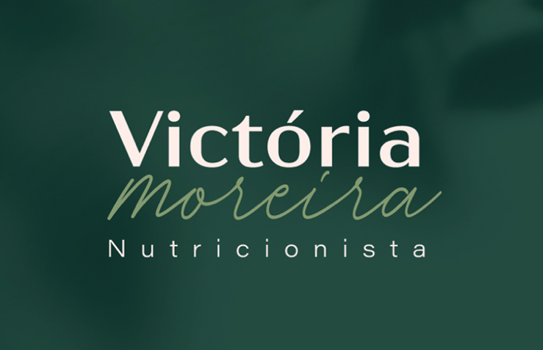
https://www.behance.net/gallery/130563829/Victoria-Moreira-Nutritionist/modules/739600553

The words are placed in the middle of the frame and equidistant to all sides of the borders.

- Symmetrical Balance (Mirror)

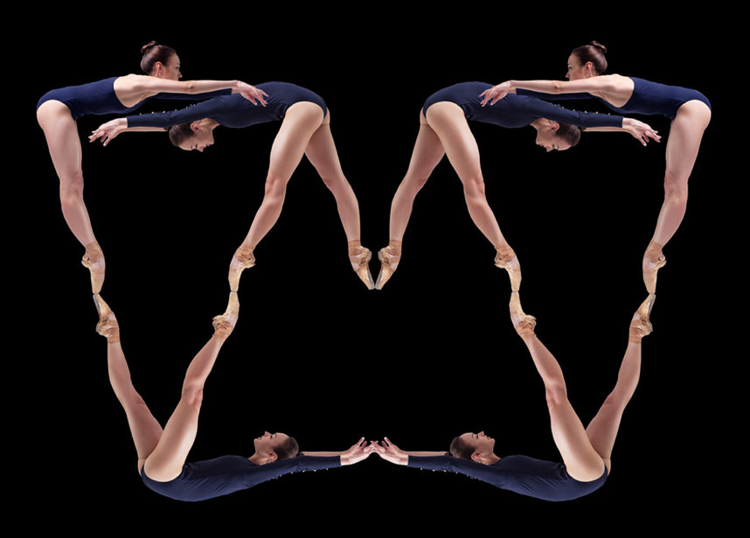

https://www.behance.net/gallery/108563535/Balancing-Acts/modules/622091699

Symmetrical Balance in mirror form is unique because of the ability to place a mirror in the middle of the image and still have it be an exact replica of the original image.

- Symmetrical Balance (Visual)
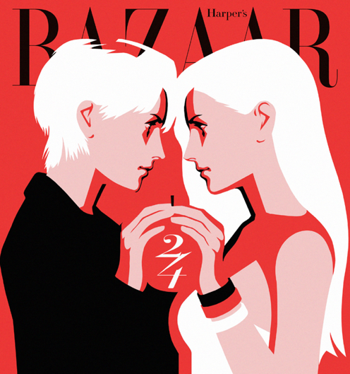

https://www.behance.net/gallery/98524075/Harpers-Bazaar-Korea-24th-Anniversary-Illustration/modules/643050105

Visual symmetry only differs from mirror symmetry by using a similar image instead of the exact same one. This image shows the digital visual symmetry of characters aligning with their features.

- Asymmetrical Balance

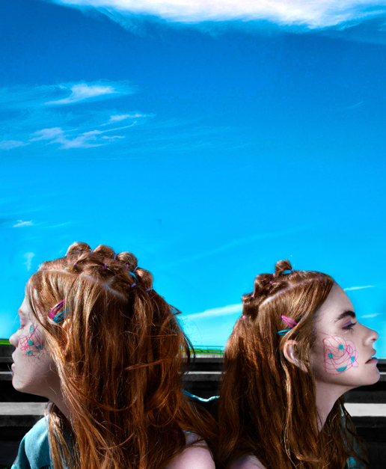

https://www.behance.net/gallery/75589917/Asymmetrical-Siamese/modules/439289675

This picture shows the balance between the girls except one girl appears slightly larger than the other and turned away from each other making it balanced but asymmetrical.

- Radial Balance

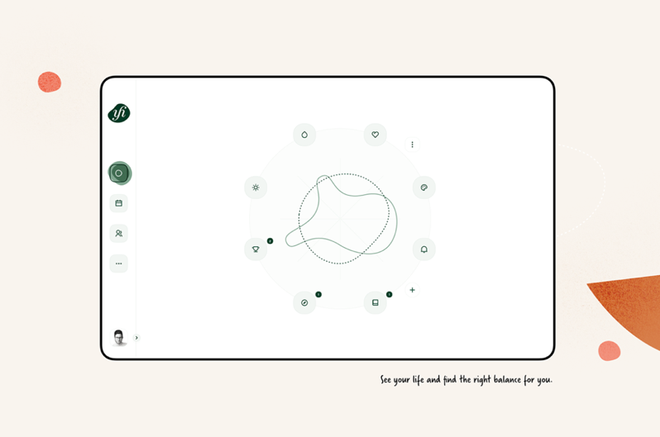

https://www.behance.net/gallery/90323761/Your-Harmony/modules/522227239

Radial balance is when there is a main focus surrounded by many branches.

Experiments

Balance: Symmetrical Balance (Mirror)

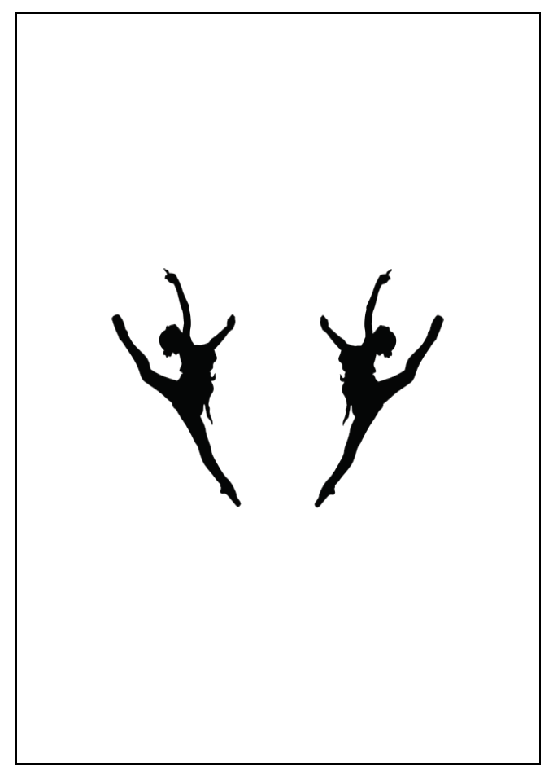

Balance: Symmetrical Balance (Visual)

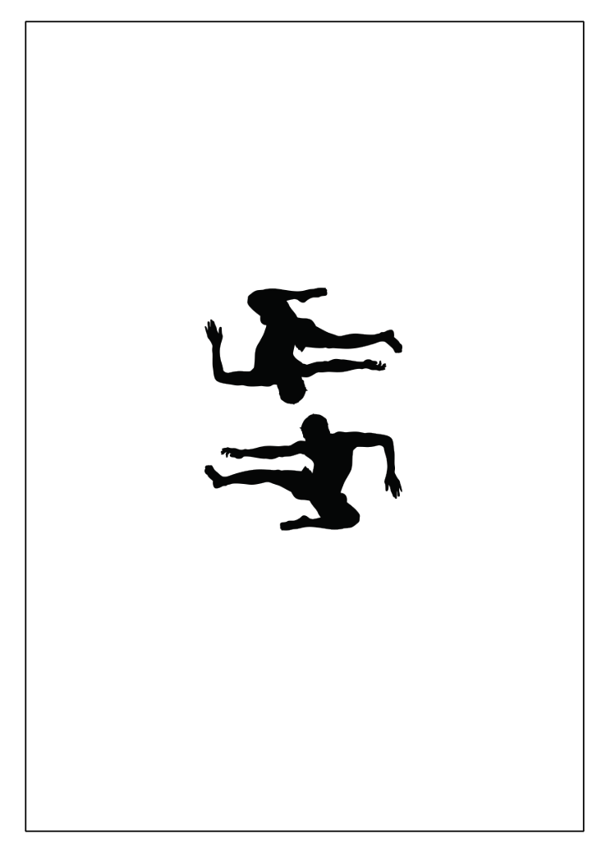

Balance: Radial Balance

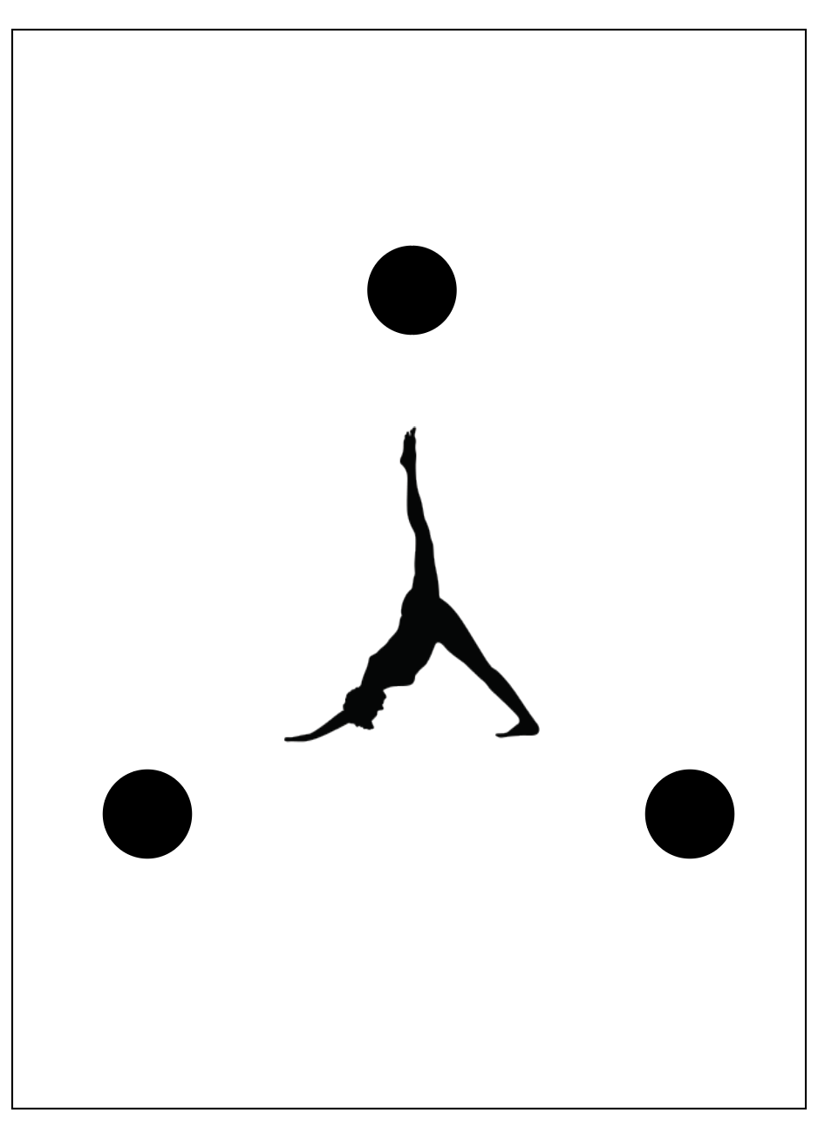

Balance: Asymmetrical Balance
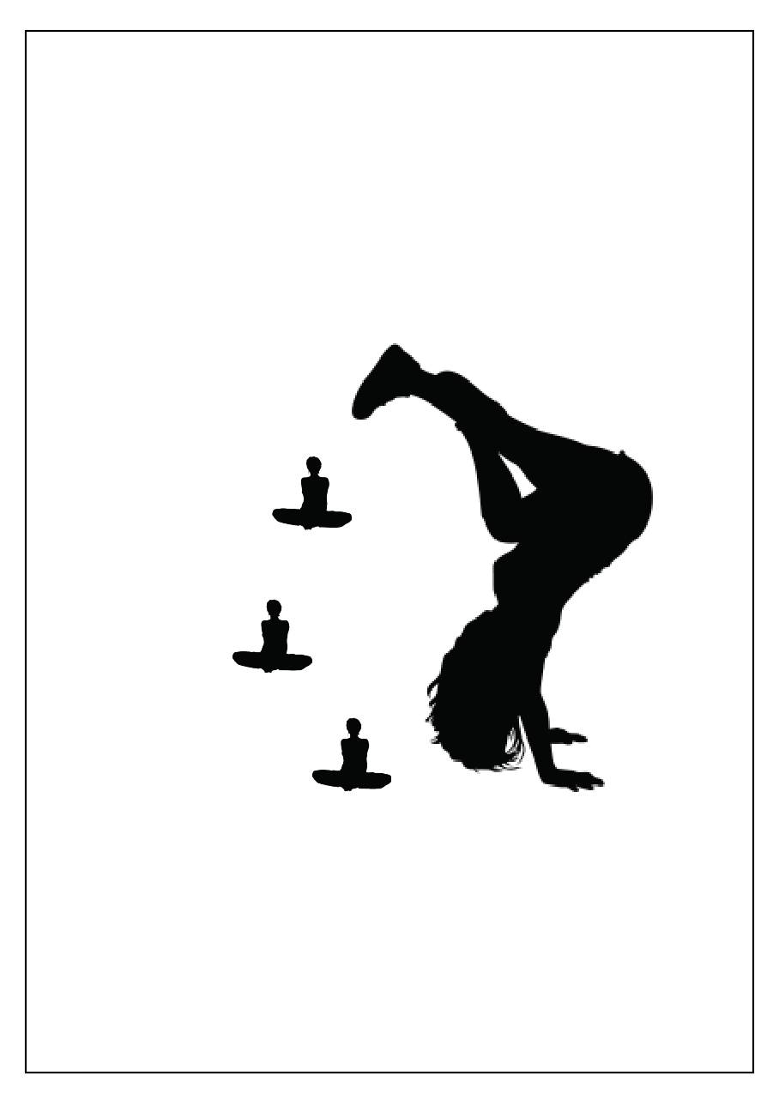

Alignment: Center Alignment
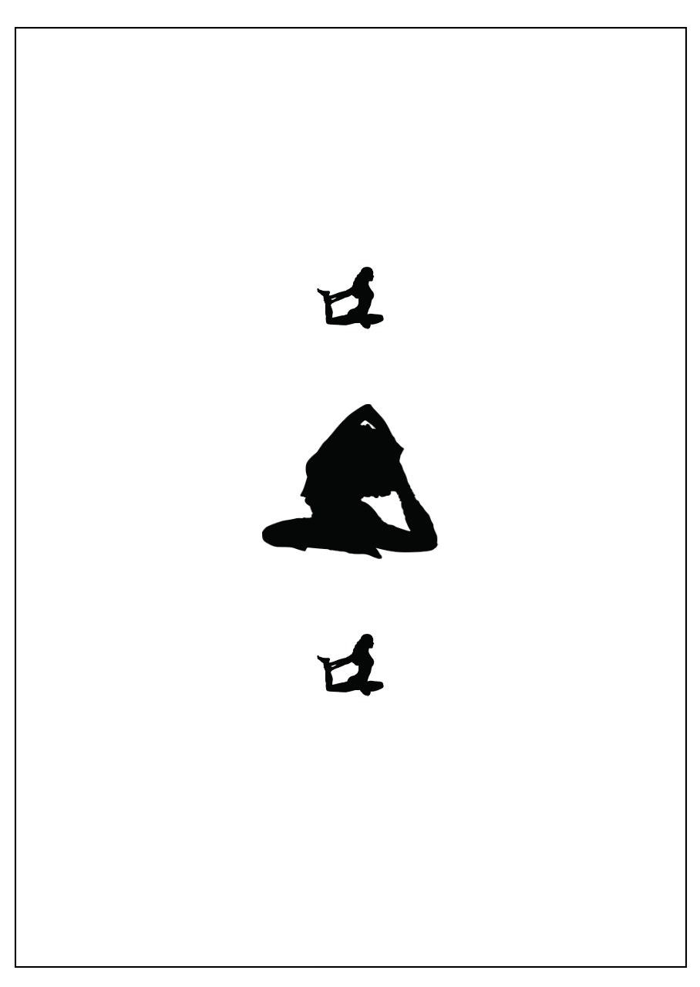

Alignment: Edge Alignment & Visual Alignment
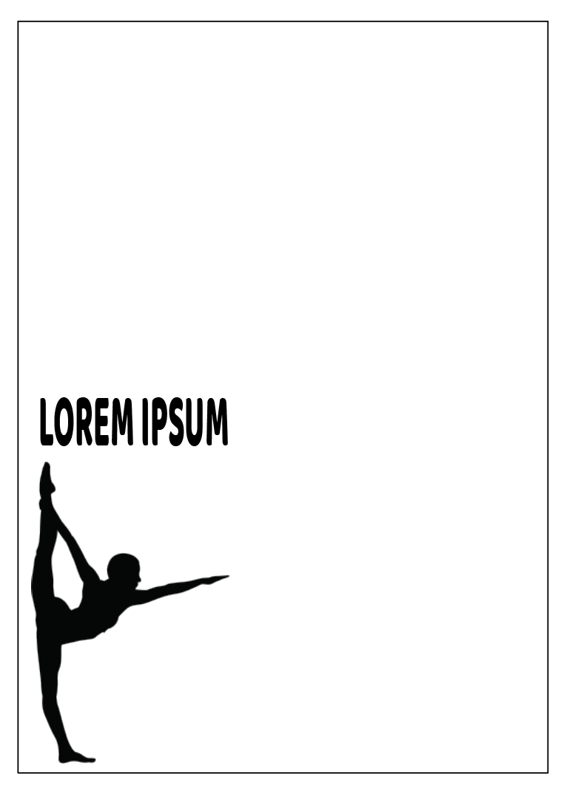

Visual Hierarchy: Scale
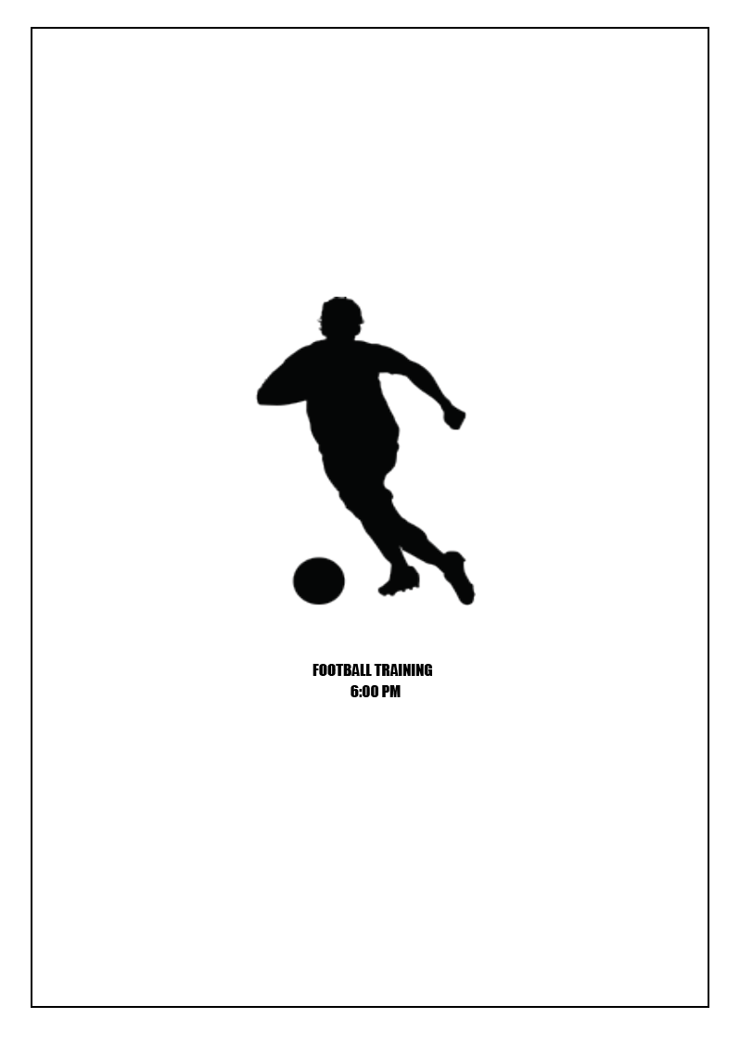

Visual Hierarchy: Shape
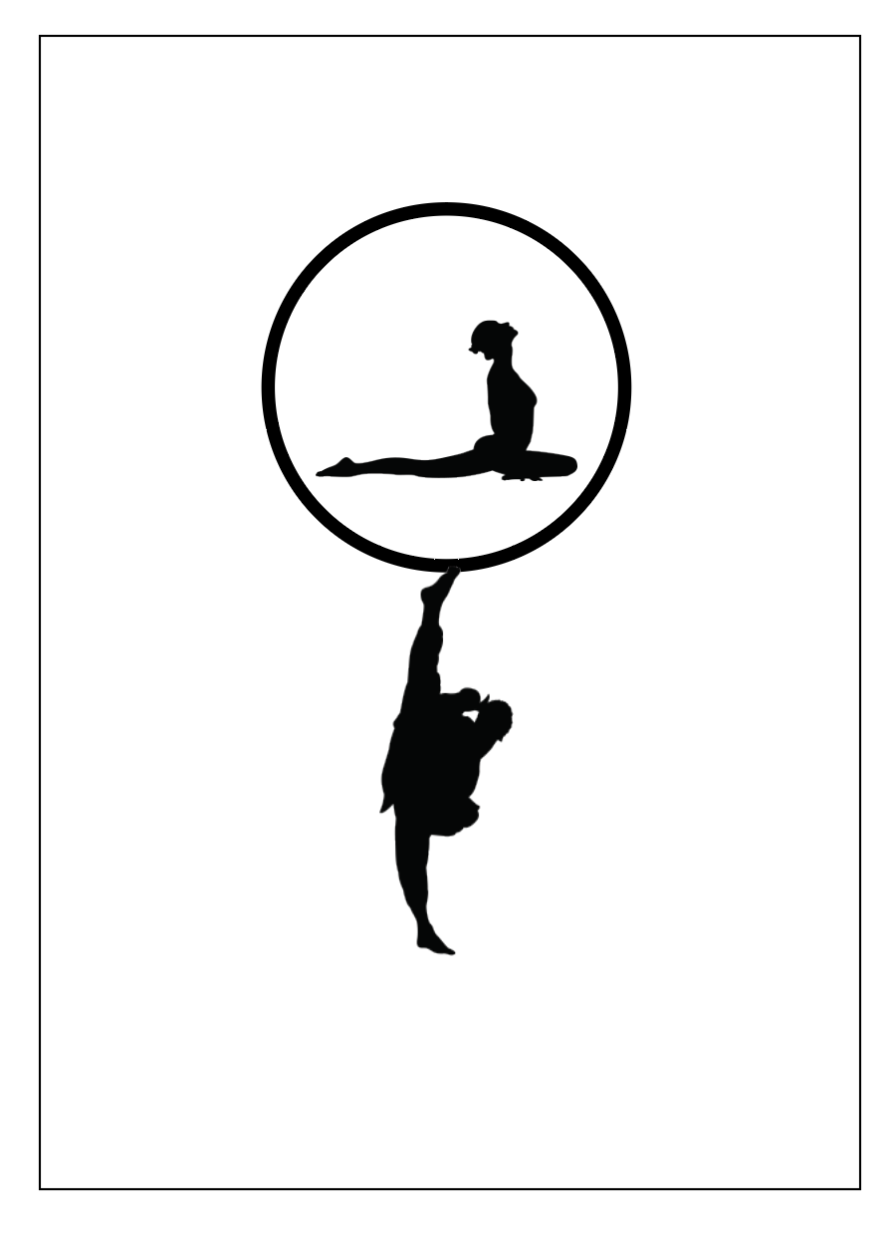
Visual Hierarchy: Colour
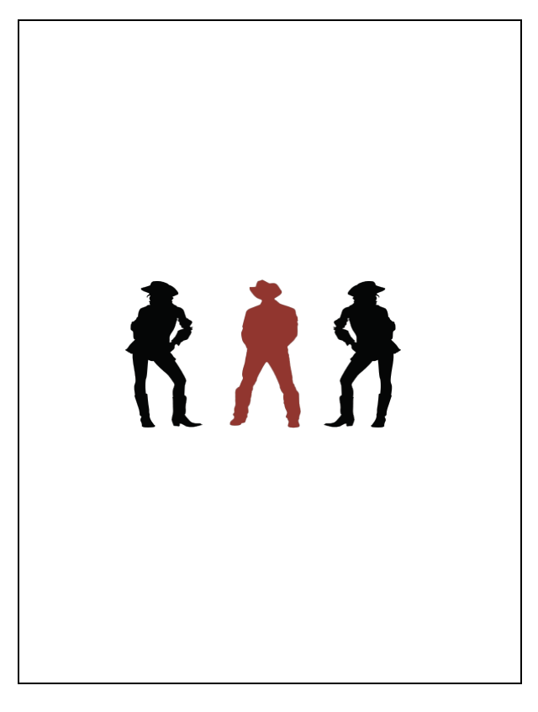

Visual Hierarchy: Contrast
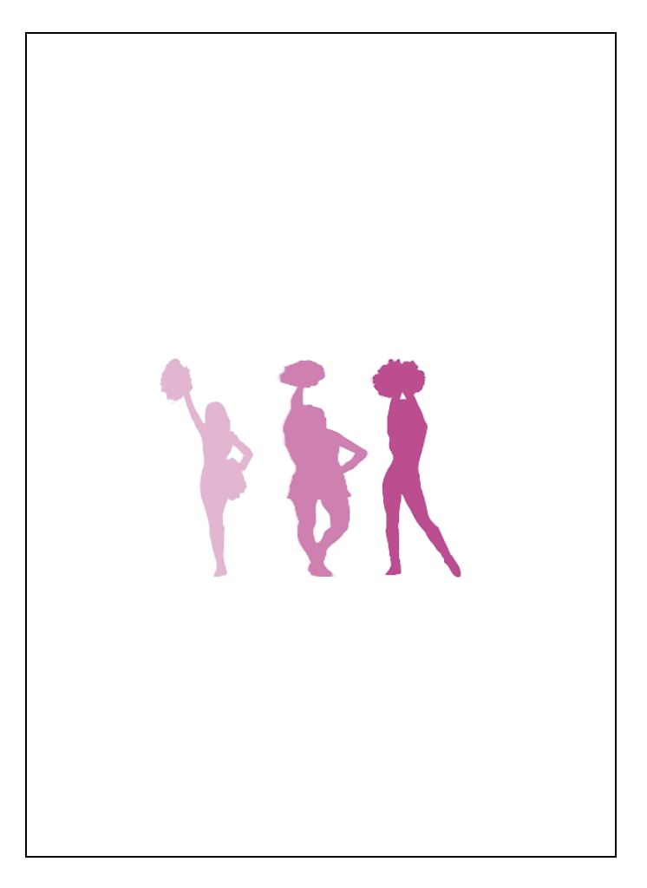

3 - Generating ideas

Components (What?) | Known or possible solutions (How?)
Word and/ or letter elements | MARIAM FASHION | MARIAM FASHION | MARIAM FASHION | MARIAM FASHION
Picture elements: objects | 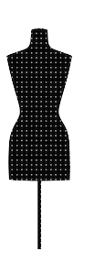 | 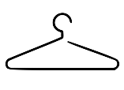 | 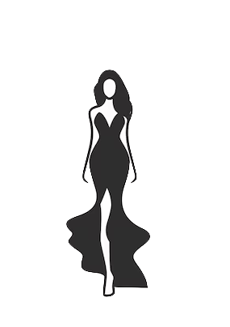
Picture elements: Wardrobe items | 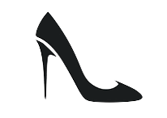 | 

Picking a font was pretty simple, as the ones I liked most were similar. I decided to go with ‘Athelas’ because I found it more fitting for a fancy fashion appeal. I tried to incorporate the mannequin in the logo as the ‘I’ in both words however, it was not as I imagined. After playing around with the objects and items, I found that using the heel as the ‘A’ made the logo unique.

4 - Illustrator Tracing & Geometrics
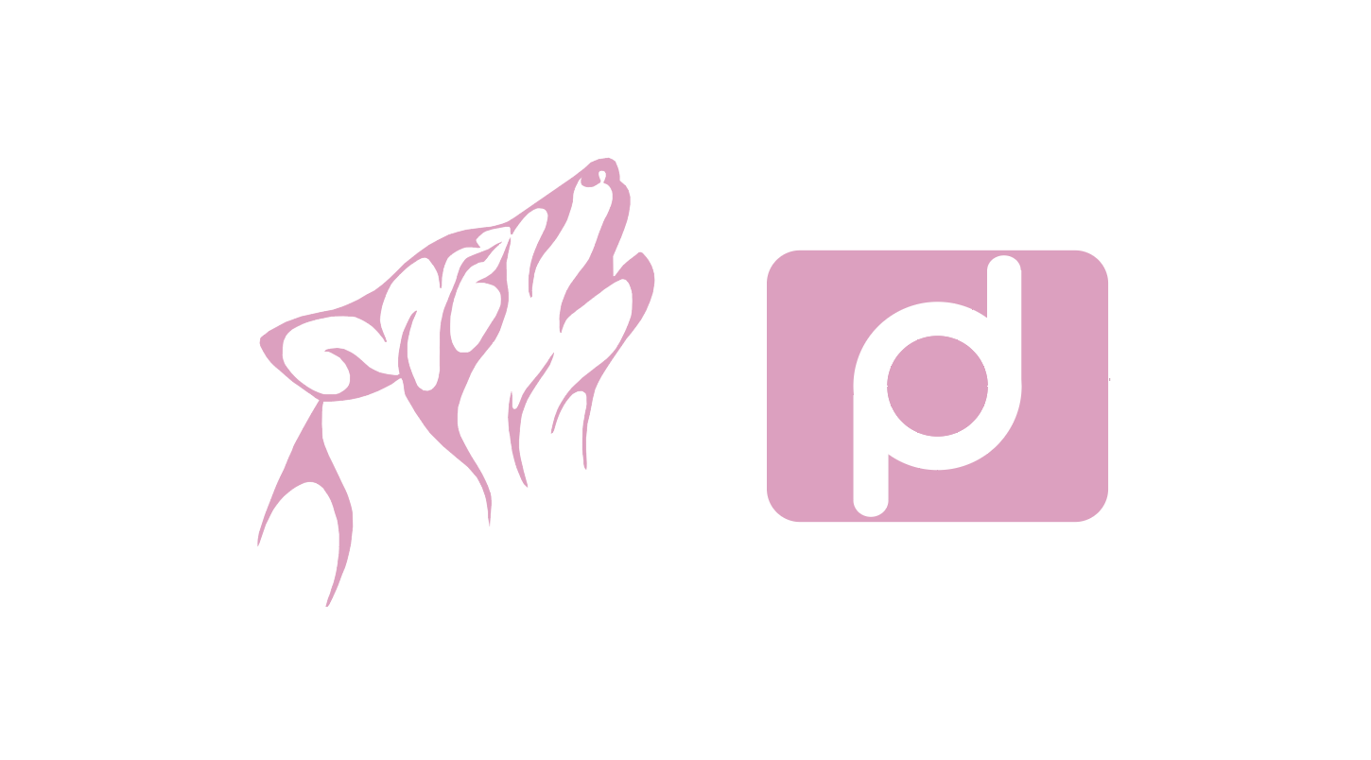
This workshop was beneficial in many ways, as it was my first time working with Adobe Illustrator or any software. Vector tracing took me a bit of time to grow accustomed to, but with time and practice throughout the workshop, I learned the techniques of curving the anchors and paths to form the actual shape of the image, and it was a fast process from then. Geometrics was a bit confusing at first. I was having issues with the Pathfinder tool, and everything kept on blending in together. After playing around with the shapes, I finally got the square and circle to work and began tracing the lines to form the top and bottom parts of the logo. However, once I was tracing, I realized that I could use the rectangle tool instead of tracing, and it made the process even easier.

5 - Color Challenge

This workshop was helpful because it gave me insight into the different types of color theory and the proper way to use and identify each one. I practiced identifying color theories by studying multiple pictures and attempting to define them on my own, which strengthened my knowledge.

Colour: Analogous

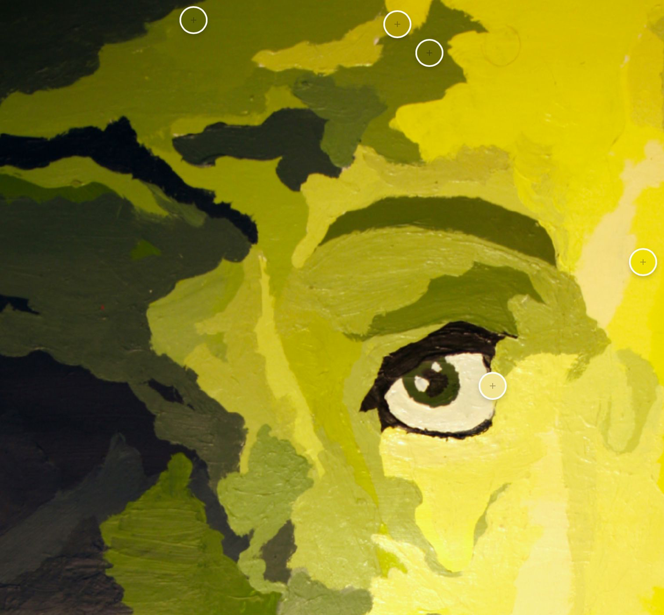

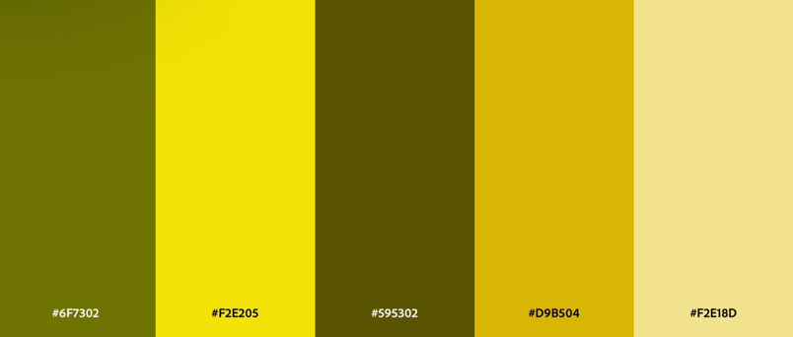

Colour: Complementary
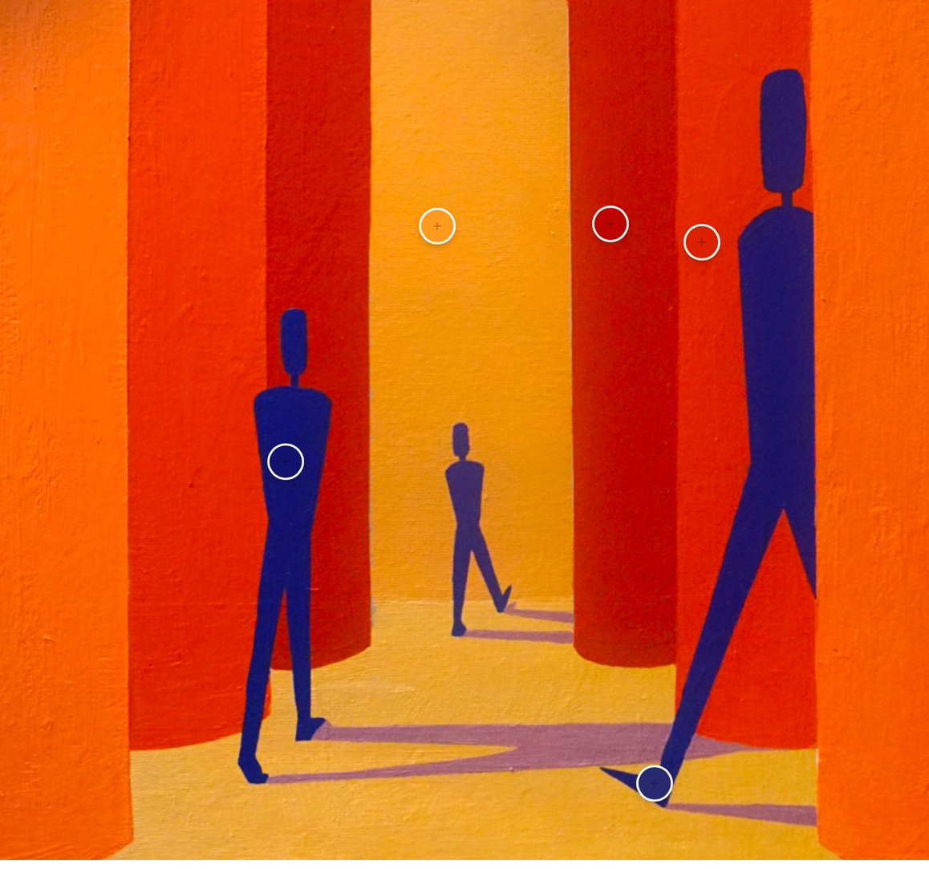

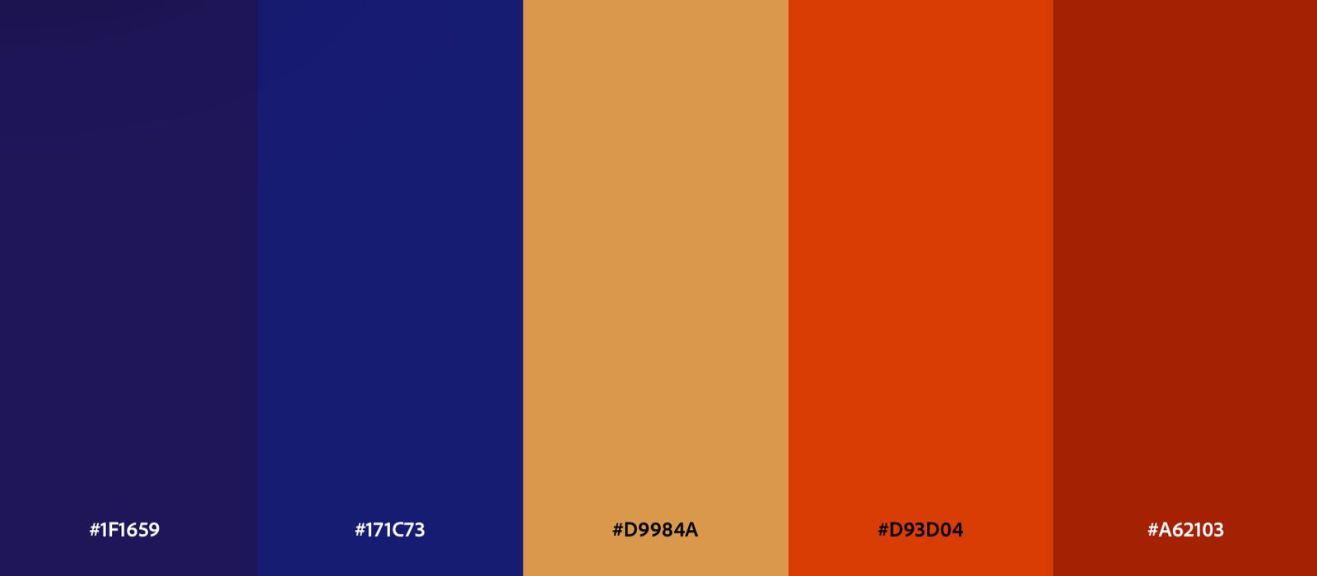

Colour: Triadic

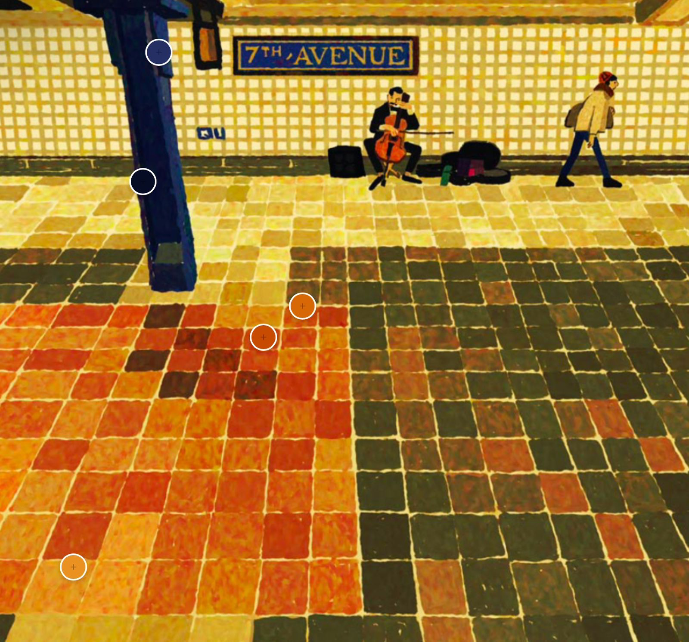

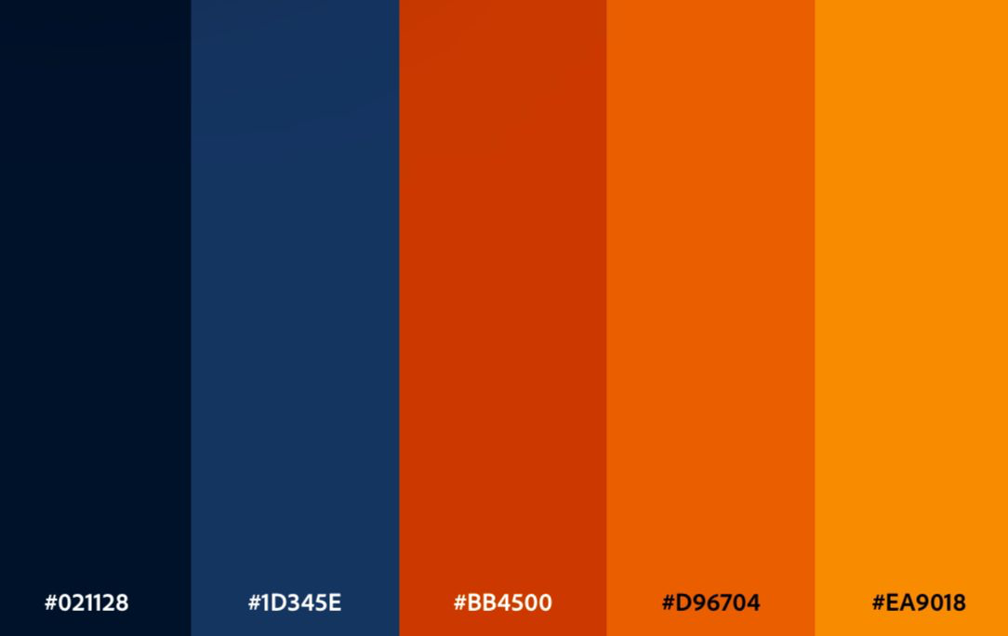

Colour: Monochromatic

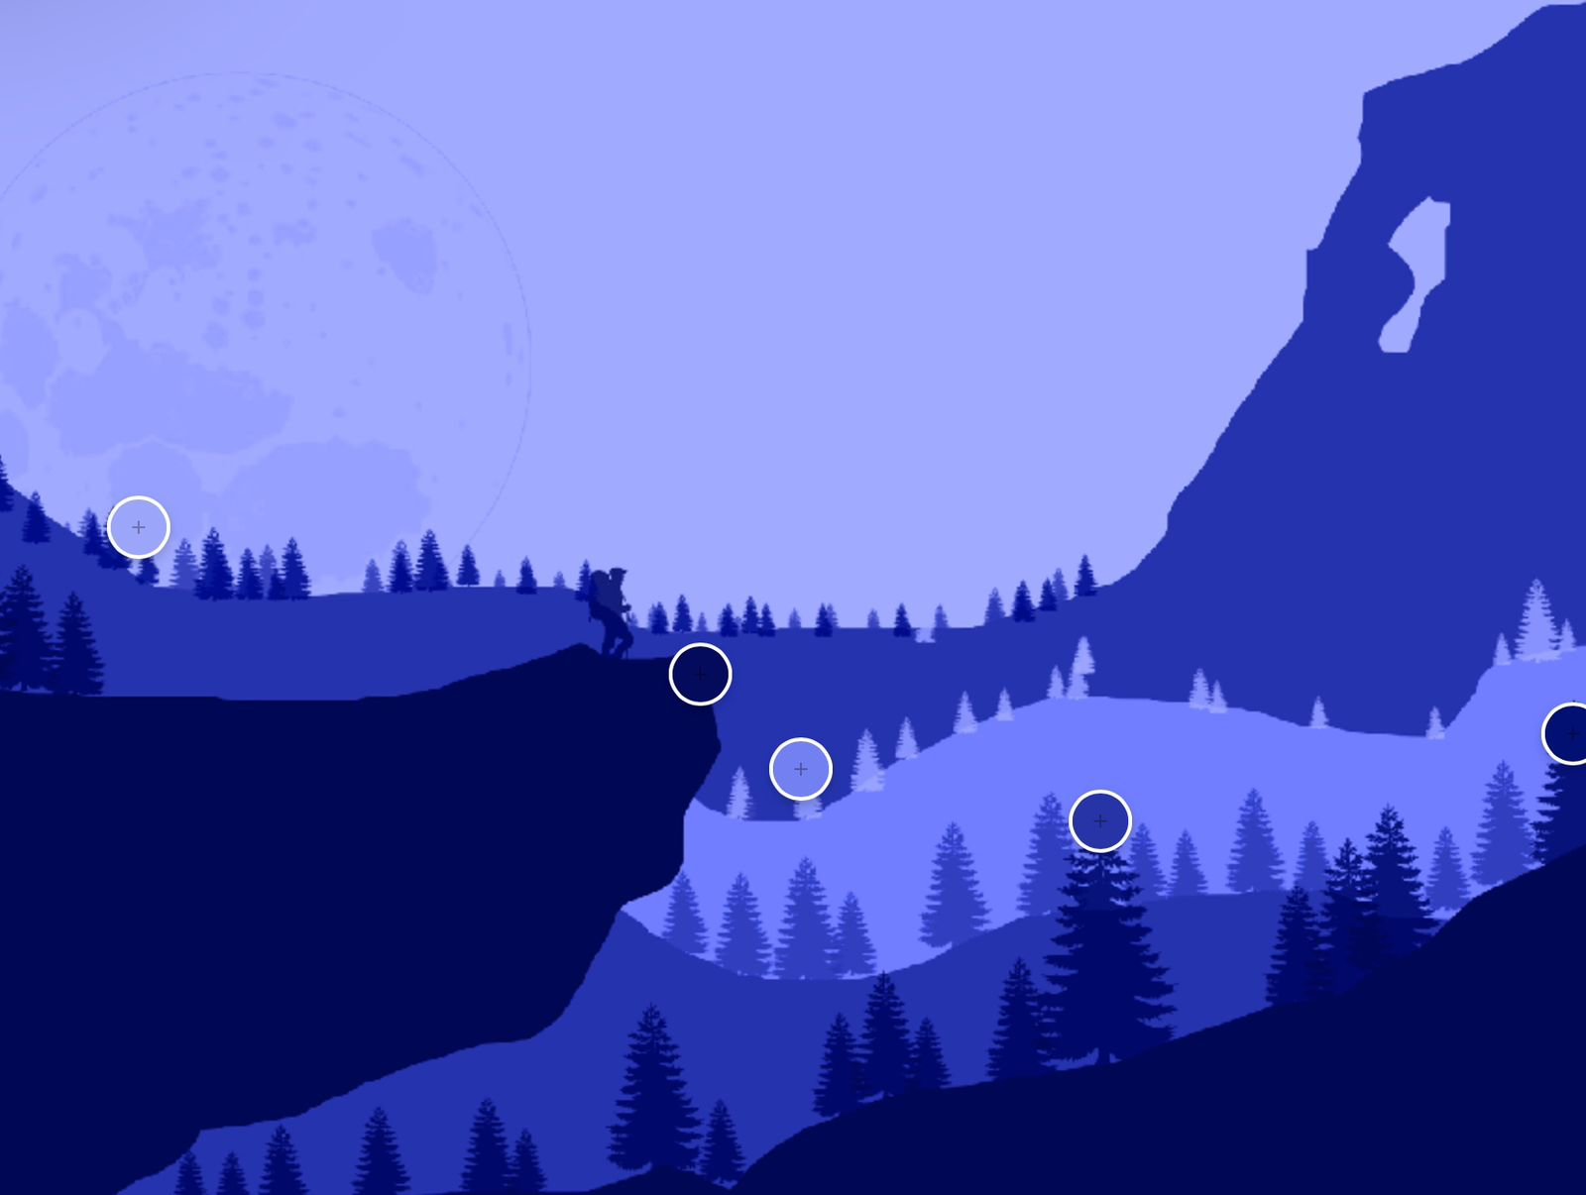

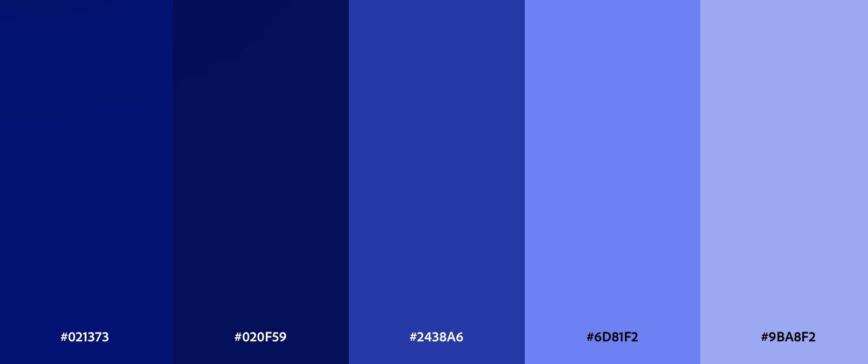

Colour: Compound/Split Complementary

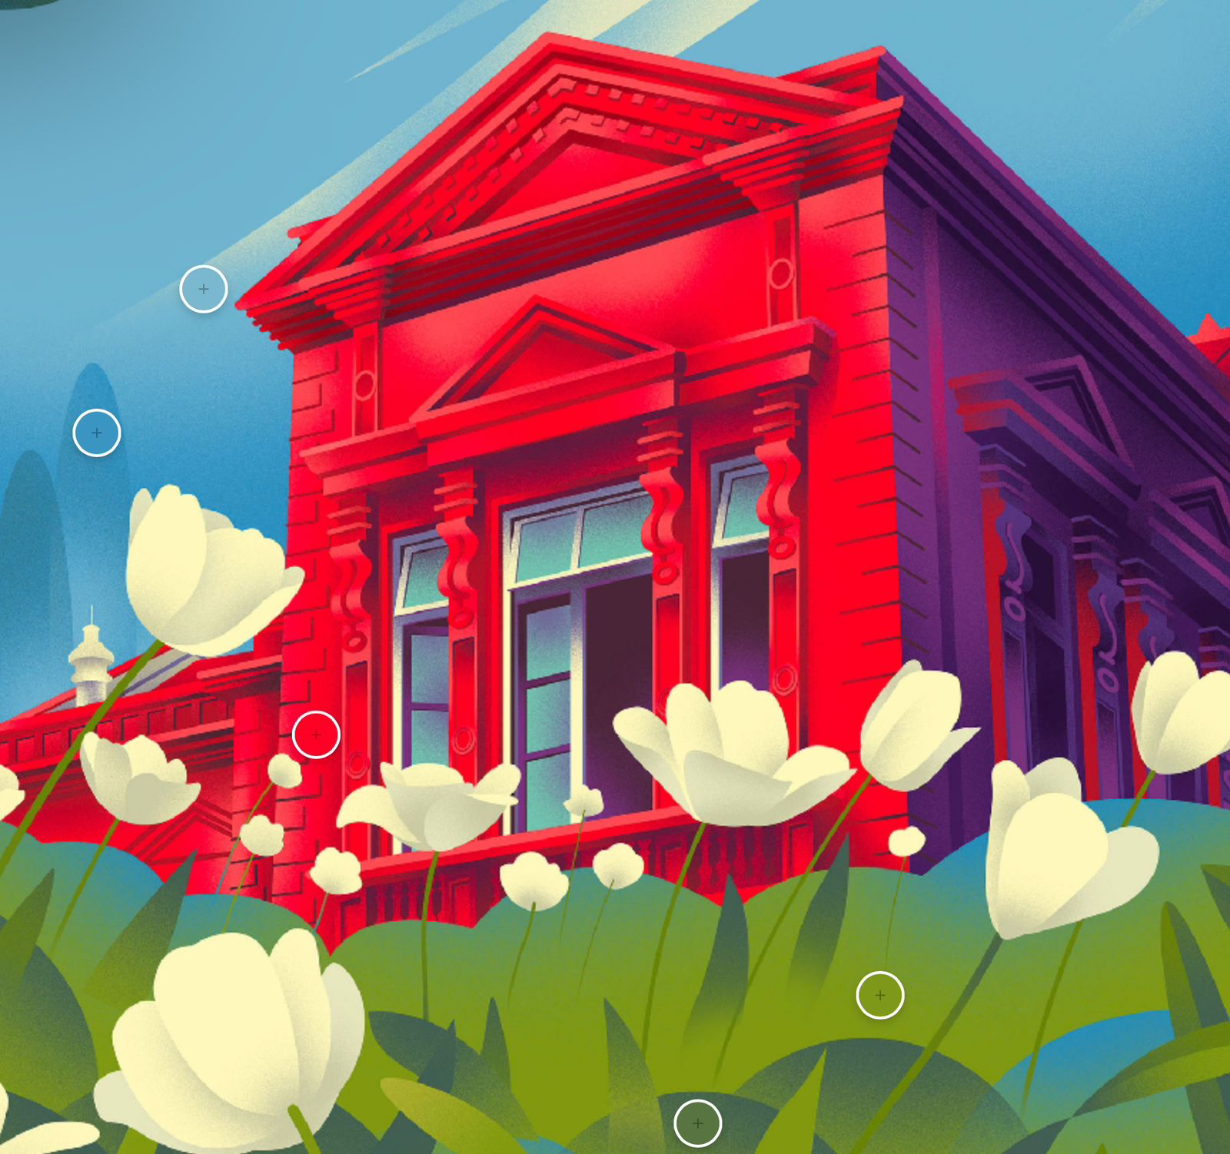

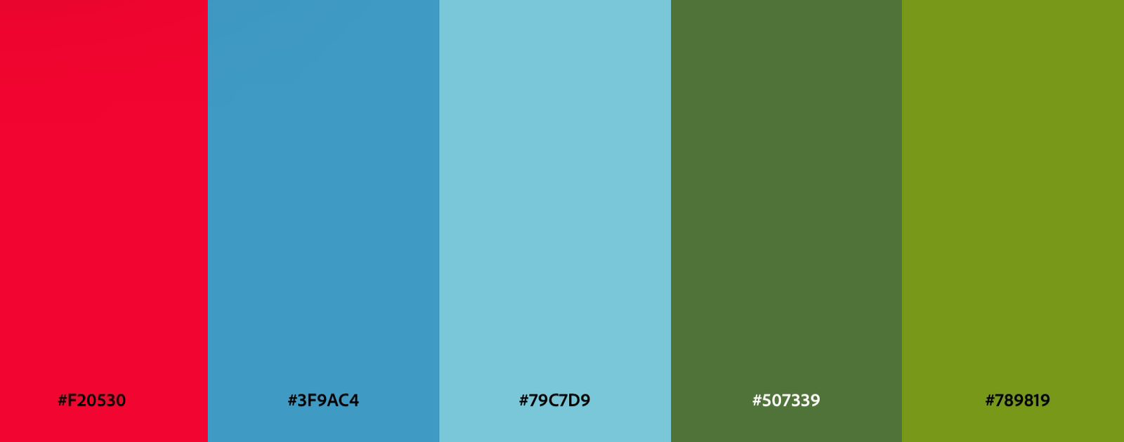

Considering all the colorways, I decided to use a color that signifies and highlights the word ‘fashion.’ When I think fashion, I think elegance and chic, and the color that resonated most with that thought was a dark shade of maroon (ac1927) that brought out the term ‘fashion’.
6 - Critique: logo design
I picked the shop ‘mariam fashion’ as the logo to redesign:

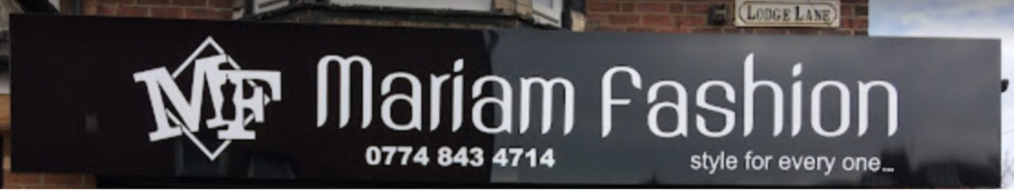

The workshop gave constructive criticism to improve my logo. My logo before the critiques:

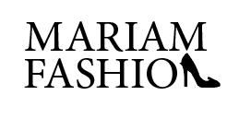
The workshop was very helpful because I knew I needed critiques but was not entirely aware of what exactly needed to be changed. My classmates suggested changing the font from ‘Big Calson’ to ‘Athelas’ and criticized that the heel being in the place of the N is not as defined and does not look like the N.

After the suggestions:

I experimented with some colors and different fonts and finalized the logo into a more concentrated logo. I made the high heel in place of the ‘A’ in both words as the high heel has more of an A shape than N. Using the heel to link both words gives off a more professional logo design
7 - Zine spreads

I incorporated visual images, texts, and graphics into my zine spreadsheets. I created columns to guide me in placing all images proportional to each other.

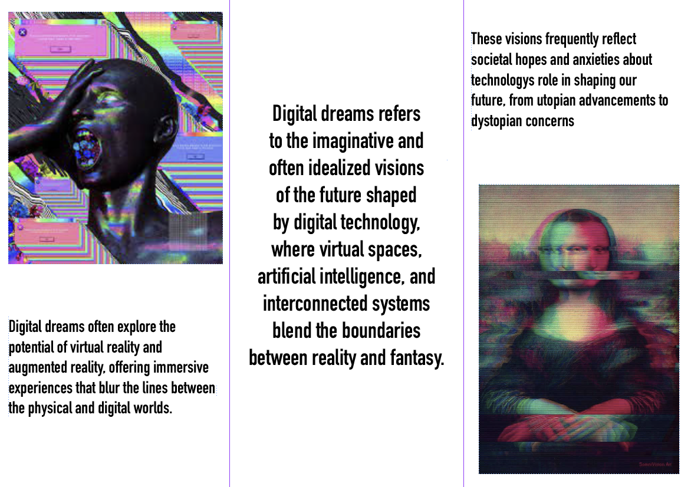

8 - Template creation

I used template creation to design the logo for my city festival, I created margins and guides to help me with equally lining the words and symbols.

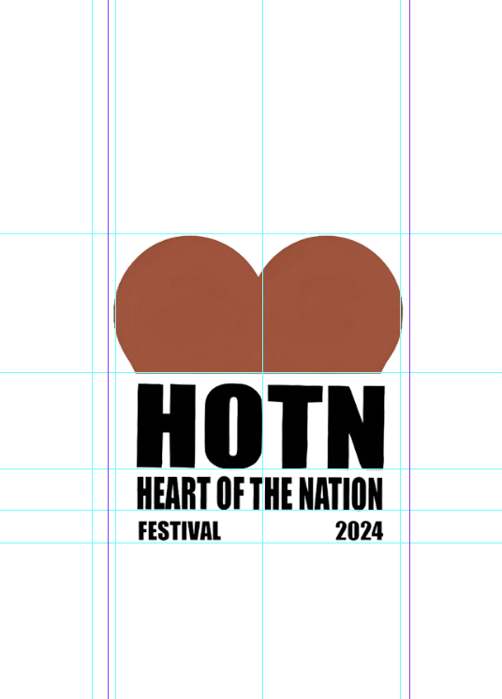
9 - Critique: social change

I found that designing an infographic was the most difficult part of this module. I didn’t have a great understanding of it and was confused about what it was that I needed to do. However, I researched some examples to get an idea and began designing.

Before the critiques:

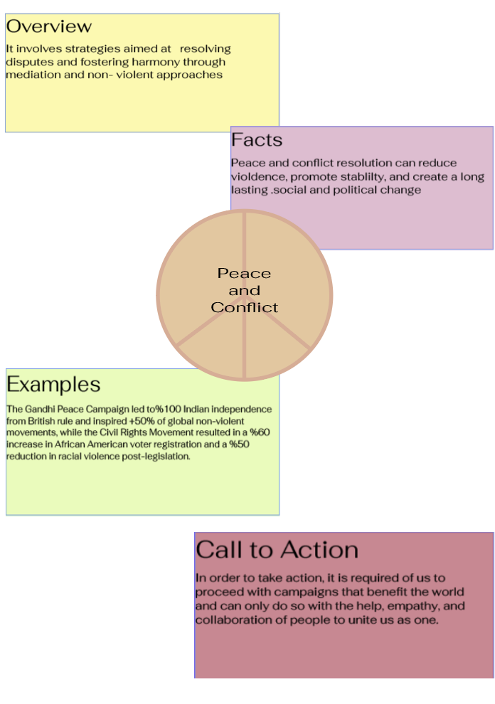

I was informed that infographics needed to include pictures and graphs so I made a graph using the line segment tool and filled it in.
After the critiques:

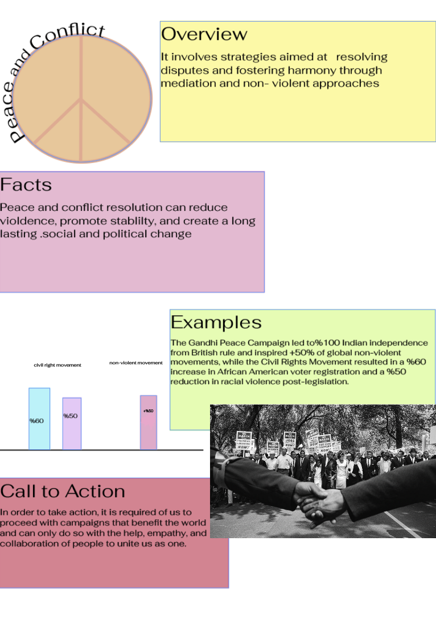

10 - Identity and aesthetics

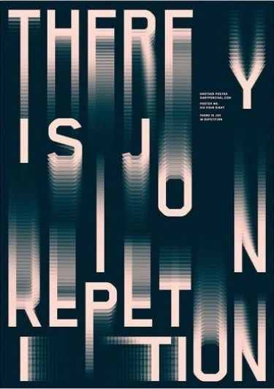

Although the phrase "THERE IS NO REPETITION" asserts that there is no repetition, the typography itself repeats visual elements like blurred effects and capital letters creating a rhythmic pattern that feels both familiar and fragmented; the spatial arrangement and alignment of the text further emphasize this rhythm, almost like musical beats; the interplay between harmony (consistent design elements) and disruption (distorted message) creates visual and conceptual tension, compelling the viewer to consider ideas about repetition, variation, and repetition.
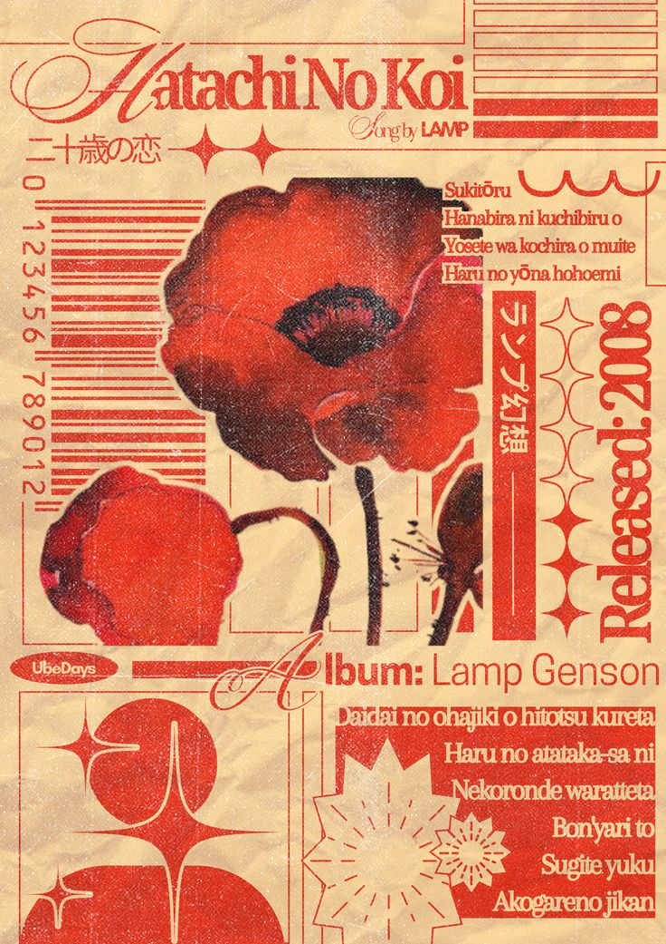

This poster's combination of typography, imagery, and cultural symbolism creates a nostalgic and visually appealing design. The bold red and soft beige color scheme evokes warmth and passion, which is in line with the main theme of "Hatachi No Koi" (Love at Twenty). The combination of bold serif and bold sans-serif fonts creates a clear hierarchy, and the inclusion of Japanese characters alongside English text reflects a harmonious blend of cultural aesthetics. The delicate poppies at the center represent transient beauty and youthful love, softening the bold composition. Decorative elements like stars, grids, and floral shapes add rhythm and balance, evoking the retro feel of vintage record covers or mid-century Japanese design. Together, these components create an emotive and lyrical tale that invites the spectator to consider love, time, and memory. The textured, paper-like background heightens the nostalgic tone, while small modern touches—like barcode-like patterns—hint at the meeting point of tradition and modernity.
11 - Compositing challenge

In this workshop, I learned new masking techniques, pixel-based and vector-based, to separate the subject from the image to use in another image. Pixel-based masking was a bit difficult at first, but once I got the hang of it, I was able to mask and select by creating a layer mask.

I picked the leaning tower of Pisa to make it seem like the man is the one tilting it. However, when it was time to piece both parts together I realized that instead of the man tilting the tower over, it would fit a lot better if the tower was being held up by the man instead.

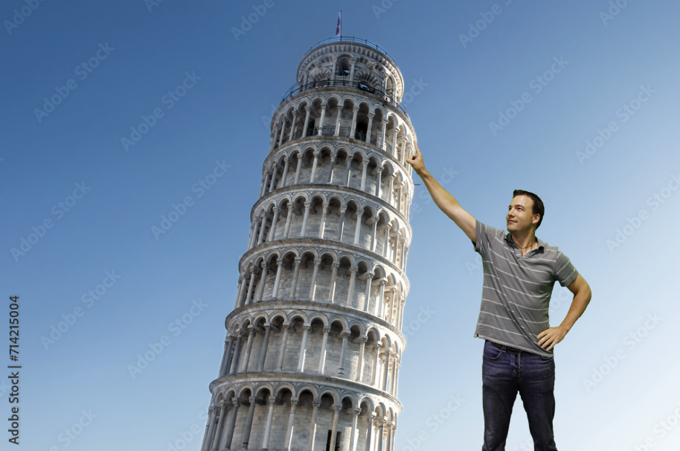

Dimensions: 4530 x 3020 px
File type: JPEG
https://as1.ftcdn.net/v2/jpg/07/14/21/50/1000_F_714215004_26bKBJmF1lZg2O0zxGeq7yER9Y2hJQgU.jpg
I enjoyed the vector-based method more than the pixel-based method. I found it simpler and easier to use the tools of the vector method and thought that it was a faster and cleaner way of masking images.

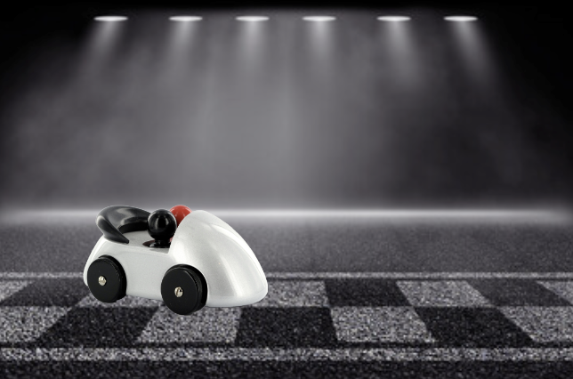

Dimensions: 3217 x 2145 px
File type: JPEG
https://as2.ftcdn.net/v2/jpg/05/71/18/87/1000_F_571188789_CqZMQt8kg594UuP2mLvy6QP2NDoh1Bn7.jpg

12 - Critique: Speculative Futures

Before the critiques, I was under the assumption that my design did not need any changes. Fortunately, constructive criticism is always helpful and guided me to change my design for the better. My idea is surrounded by the idea of ‘What if technology advances enough for futuristic calls?’ I used a picture of a man looking surprised on Facetime when he sees the hologram, but I was advised to change it to a happier emotion as in the future hologram calls would cheer a person rather than surprise them.

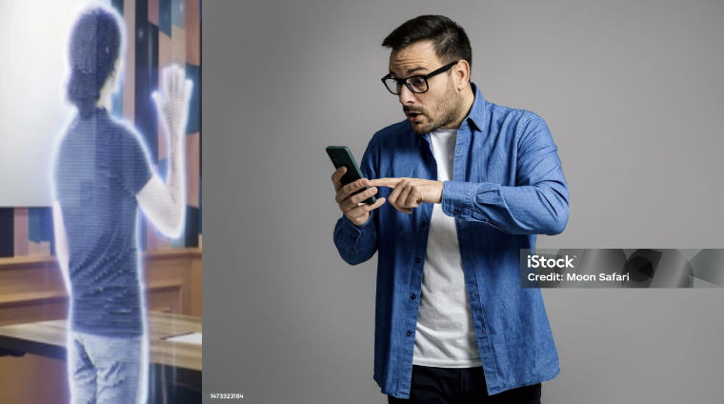

https://media.istockphoto.com/id/1473323184/photo/shocked-mid-adult-man-wearing-denim-shirt-and-eyeglasses-reading-bad-news-while-texting-over.jpg?s=612x612&w=is&k=20&c=wVVRk0-1U4Q7dlfNxeM7gWmYjdiX5MOoQXWCTYkIYMs=

https://www.shutterstock.com/image-photo/asian-woman-talks-on-call-her-2211249827
After the critiques:

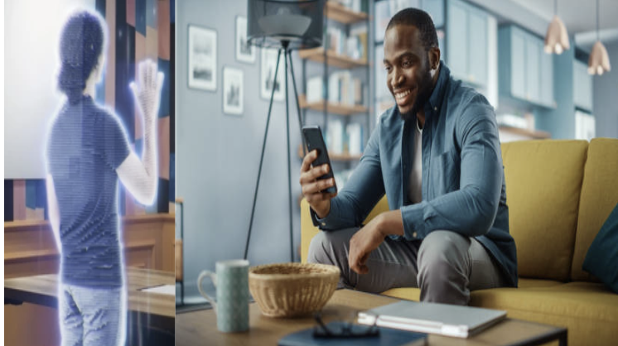

https://media.istockphoto.com/id/1311088144/photo/excited-black-african-american-man-having-a-video-call-on-smartphone-while-sitting-on-a-sofa.jpg?s=612x612&w=0&k=20&c=cOEIGI86M9rf-o23BmT3NvFUTvWBLv_nCB-ijcGyVM4=

https://www.shutterstock.com/image-photo/asian-woman-talks-on-call-her-2211249827

13 - Preparing images for publication

I started by cropping the image a bit, making sure to uncheck the "delete cropped pixels" box so the crop is non-destructive. Then, I use the clone stamp tool to remove the brown grass from the top right, creating a new layer so my cloning stays non-destructive. To recover the shadow details under the wings, I apply the shadows/highlights adjustment, remembering to select "convert for smart filters" before making any changes. Next, I added a level adjustment using an adjustment layer and reduced the saturation of the grass with the selective adjustment tool in the hue/saturation menu Finally, I sharpened the image using the unsharp mask.

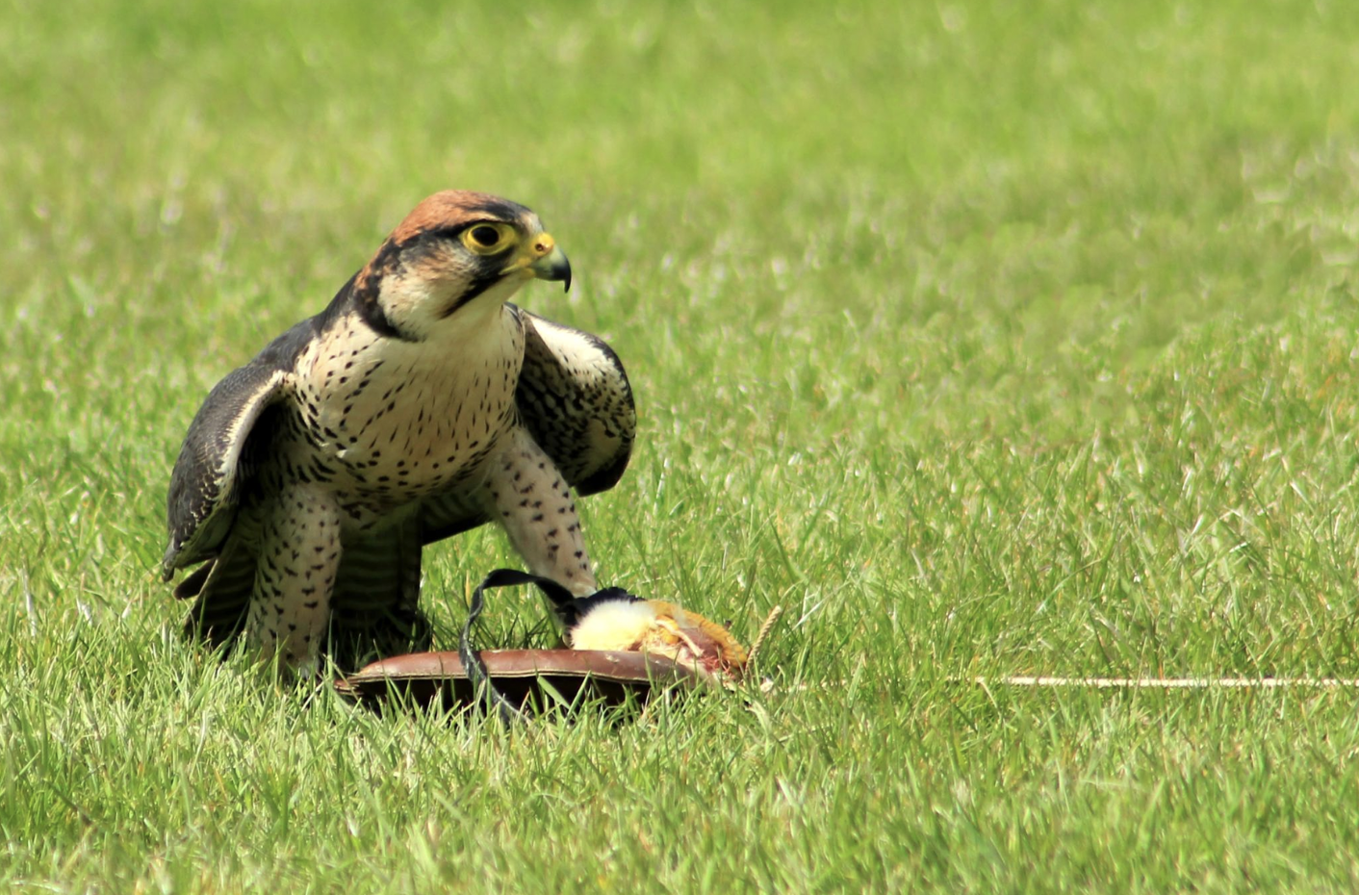

14 - Cutout challenge
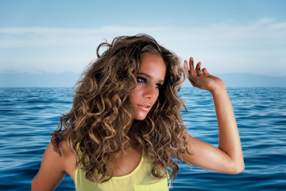

I found the cutout challenge quite difficult; first, I used the object select tool to cut out the image, then used select and mask and refine hair afterward to make the picture clearer to add to a different background.

15 - Semiotic analysis

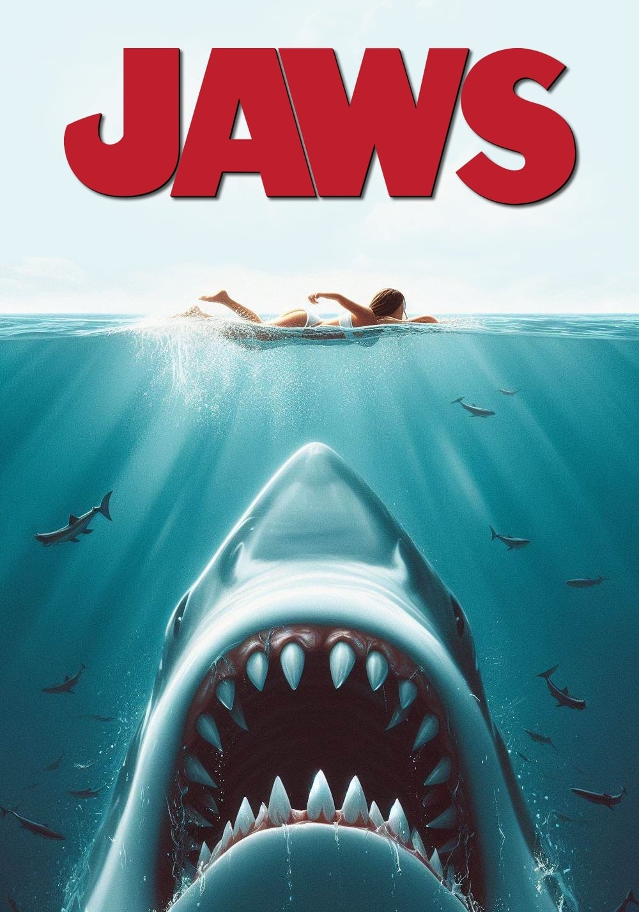

A brilliant example of semiotic design, the Jaws (1975) poster uses both written and visual components to create tension and dread. The lone swimmer stands for purity and fragility, while the shark, with its oversized size and gaping jaws, depicts primordial danger and the unknown. While the blood-red "JAWS" title implies violence and death, the black ocean emphasizes mystery and humanity's frailty versus nature. By placing the predator and its gullible victim in a vertical composition, tension is created, and the tone of the movie is instantly conveyed through the use of horror genre tropes like loneliness and looming danger. This famous poster successfully creates an emotional and psychological impact by utilizing universal symbols and cultural anxieties.
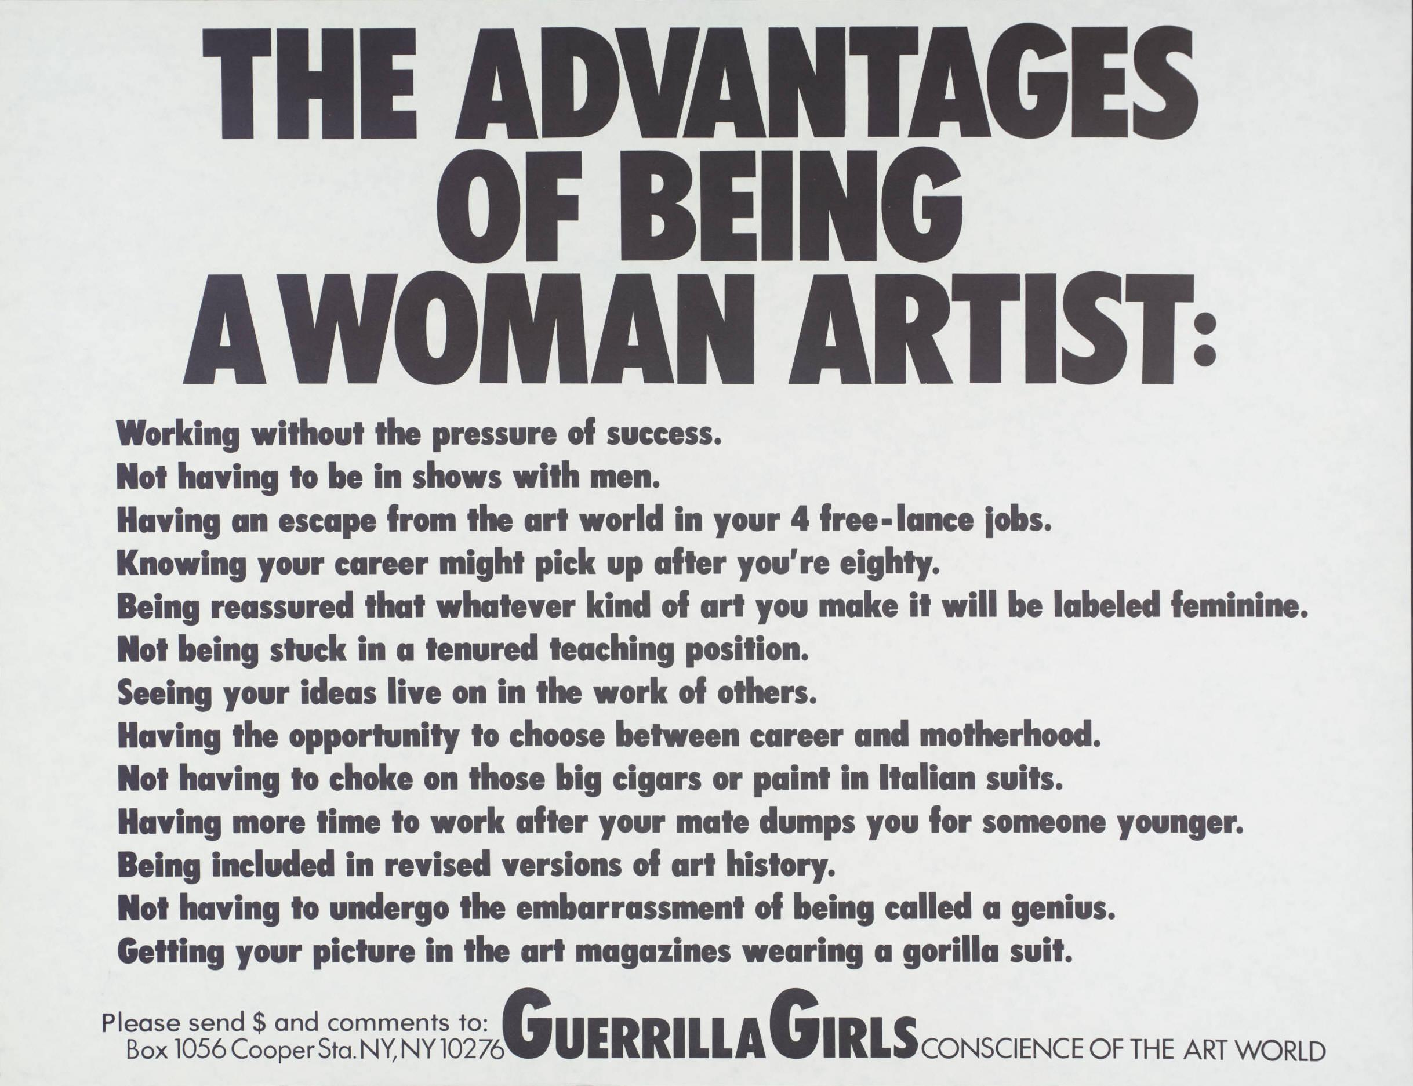

The Guerrilla Girls' "Advantages of Being a Woman Artist" poster uses semiotics to address gender inequality in the art industry. Ironic "advantages," including "Working without the pressure of success," are listed in the text, underscoring structural prejudices against female artists. While the black-and-white color palette highlights the starkness of the concerns discussed, the strong, sans-serif typography expresses urgency and assertiveness. The iconic gorilla mask emblem of the Guerrilla Girls challenges established conventions in the art world and introduces anonymity. This poster successfully conveys its feminist critique through sarcasm and minimalist design.

My festival’s Semiotics

There are many aspects to festivals and many options to choose from. Festivals bring the community closer to each other, so I thought of the best activities for people to do there. People enjoy food and rides, so I incorporated them into my design as a way of marketing the festival.

Components (What?) | Known or possible solutions (How?)
Picture elements - landmarks | 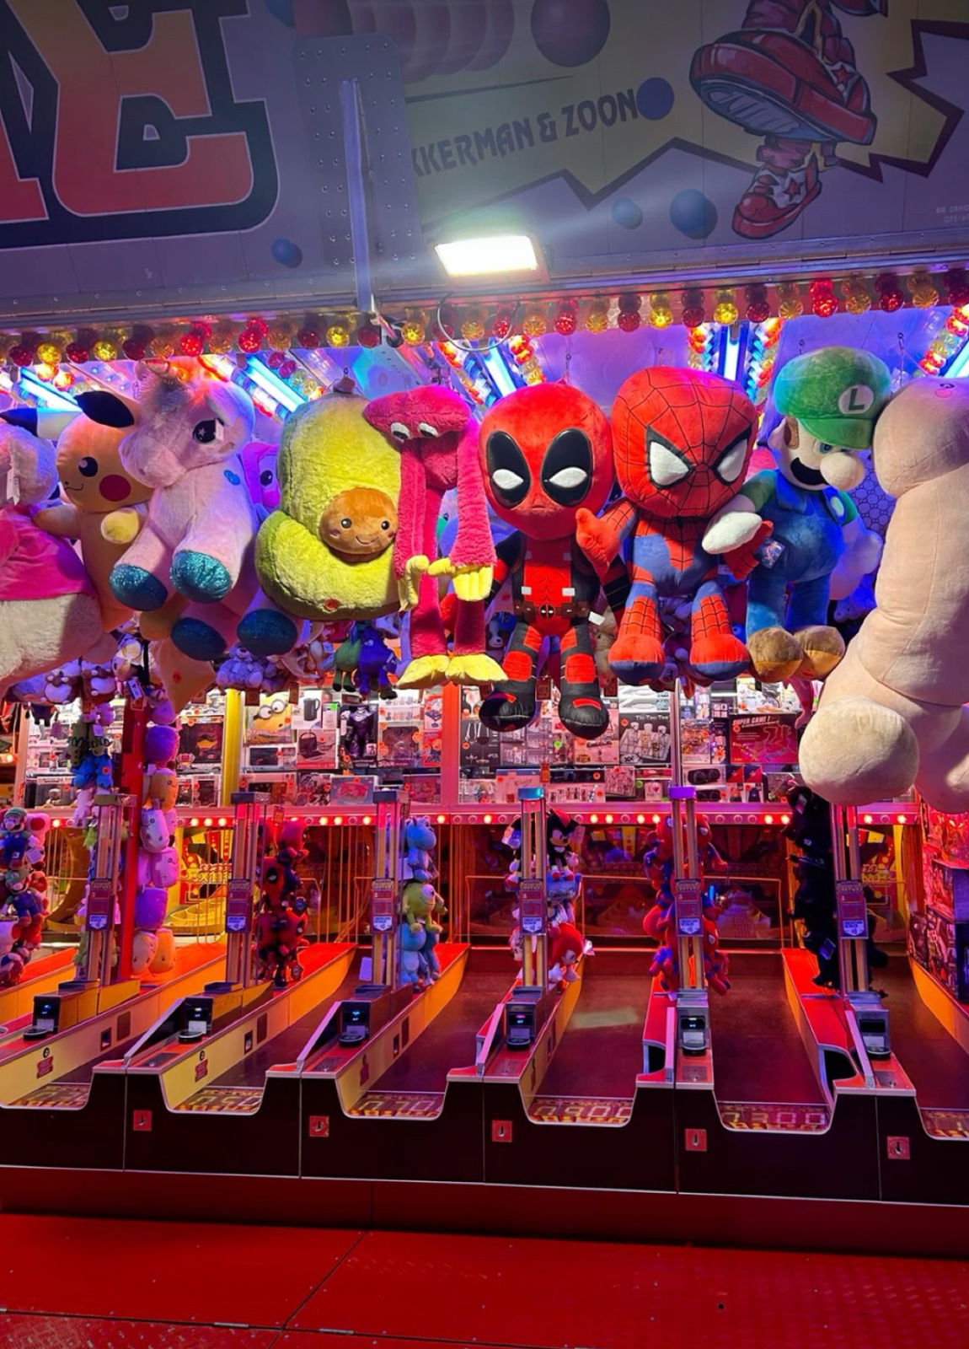 | 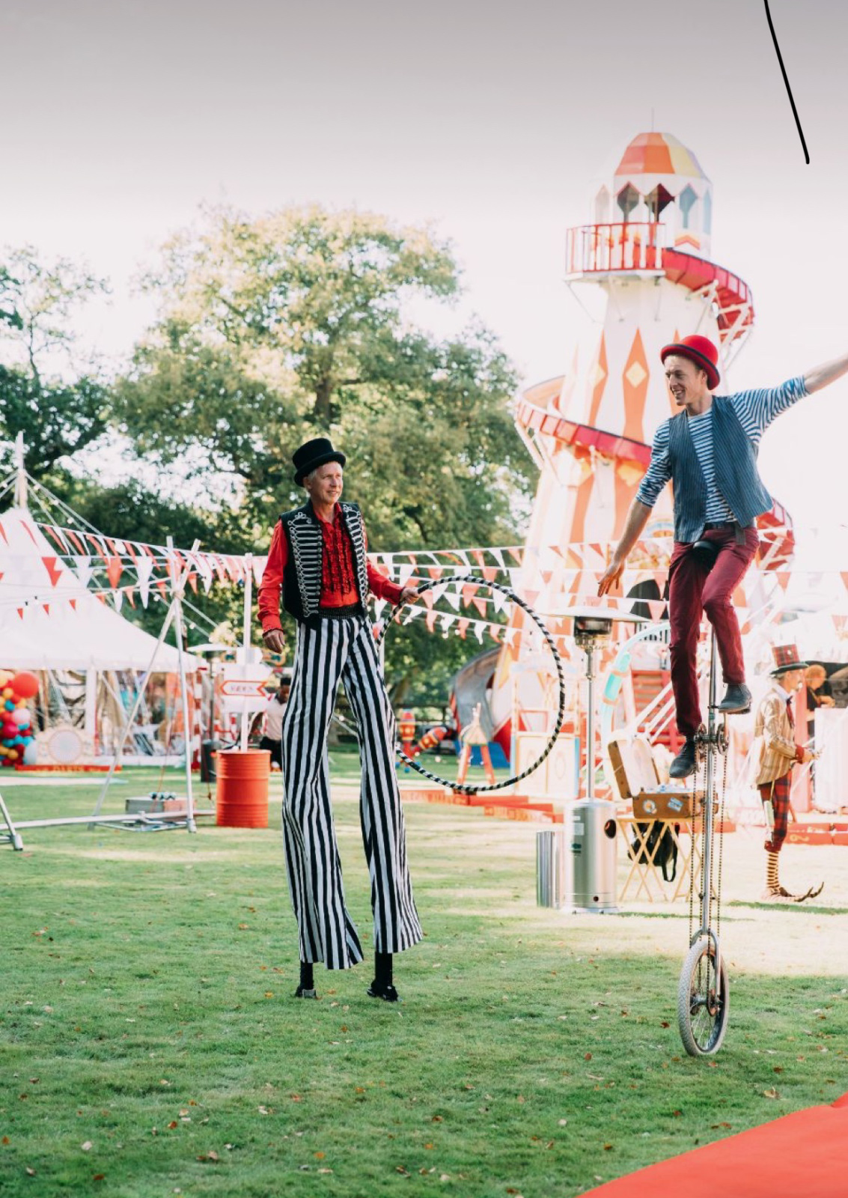 | 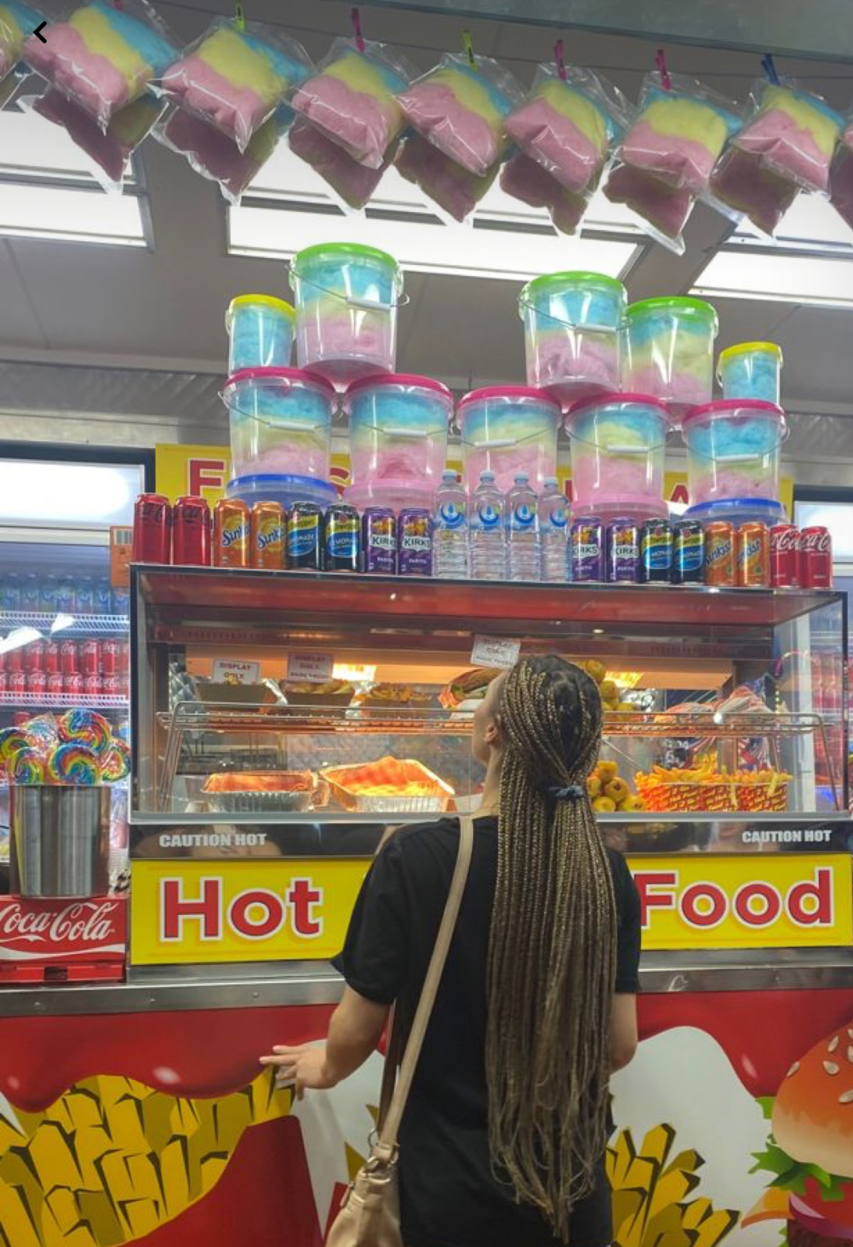 | 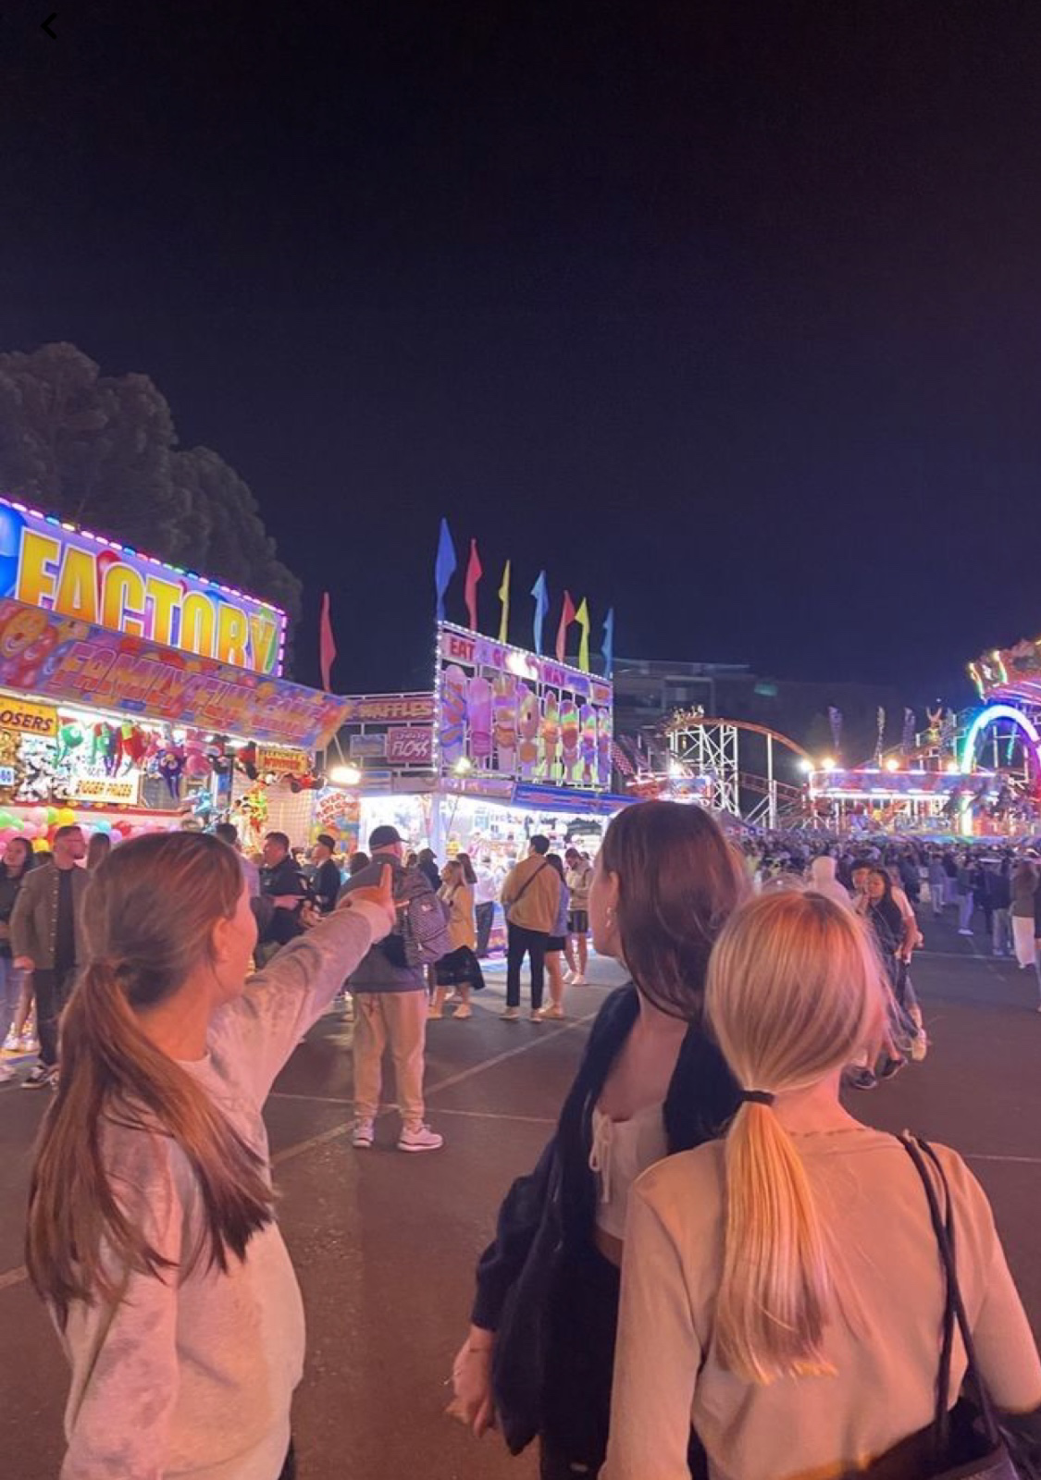
Picture elements: food | 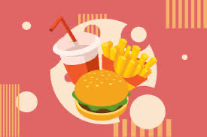 | 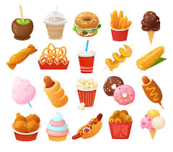 | 
Picture elements: Wardrobe items | 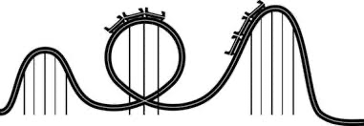 | 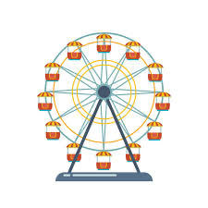 | 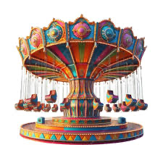 | 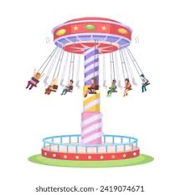

16 - Critique: Multiformat campaign

While working on the designs of my campaign I experimented with different color background and font colors to see which matched best.

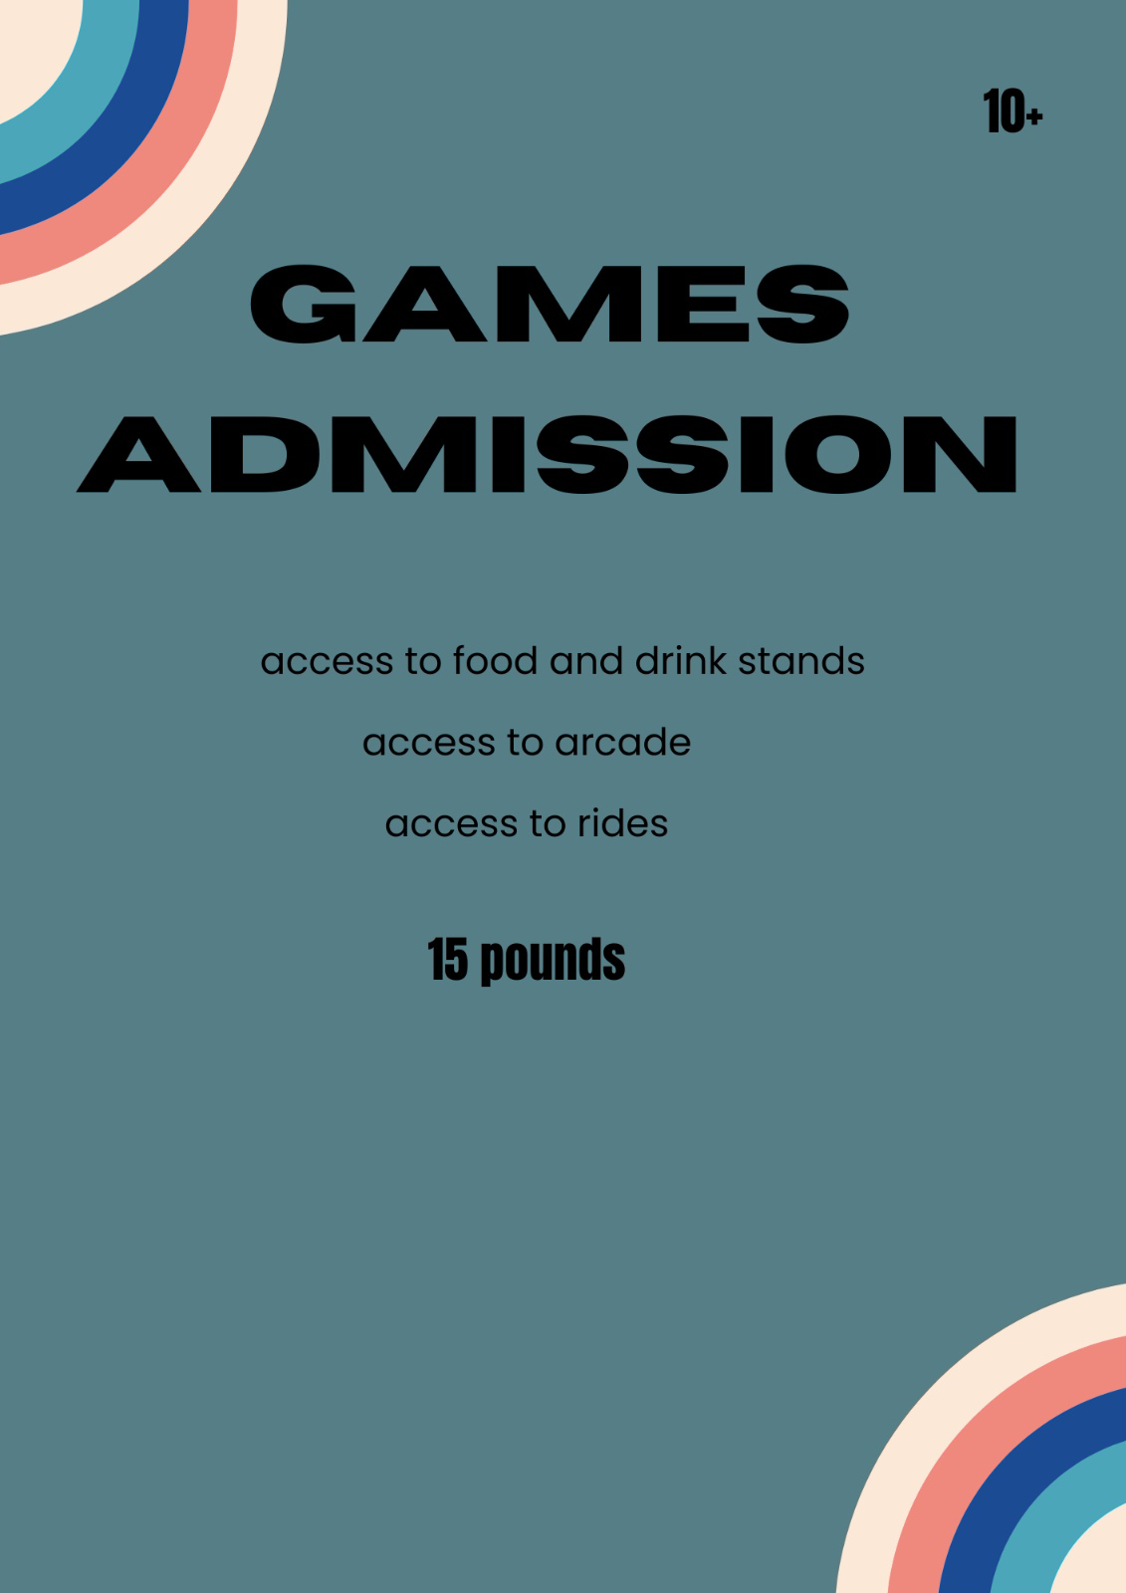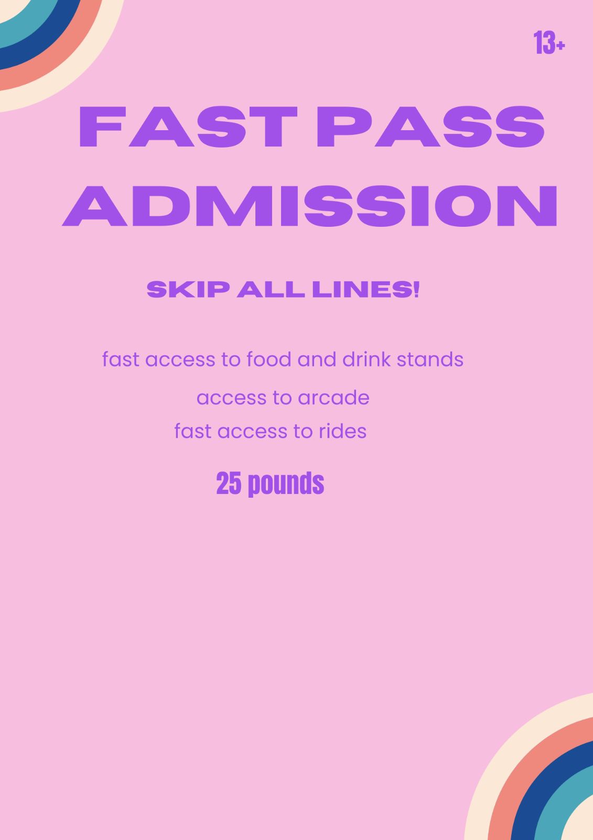

The critiques I got were to change the background color of the first image to make it brighter and fun to appear eye-catching and to change the color of the font to a pop of color to make it more inviting. With the second design, they suggested I change the color of the font since it did not match that well with the background color.

After many trials, I decided to just go with the original background color of both designs and just change the font color to match it.
After the critiques:

